Task: To install firewalld package

command: sudo apt update && sudo apt install firewalld

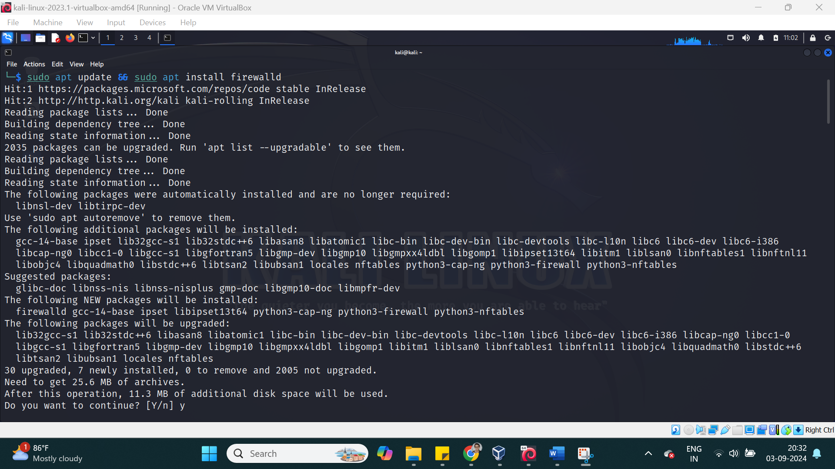

Task: To check the state of the firewall

command: firewall-cmd --state

systemctl status firewalld

Task: To start firewall

command: systemctl --enable --now firewalld

systemctl start firewalld

Task: To disable firewall

command: systemctl stop firewalld

Task: To check the status of firewall and all rules

command: iptables -L -n

command: systemctl status firewall.d service

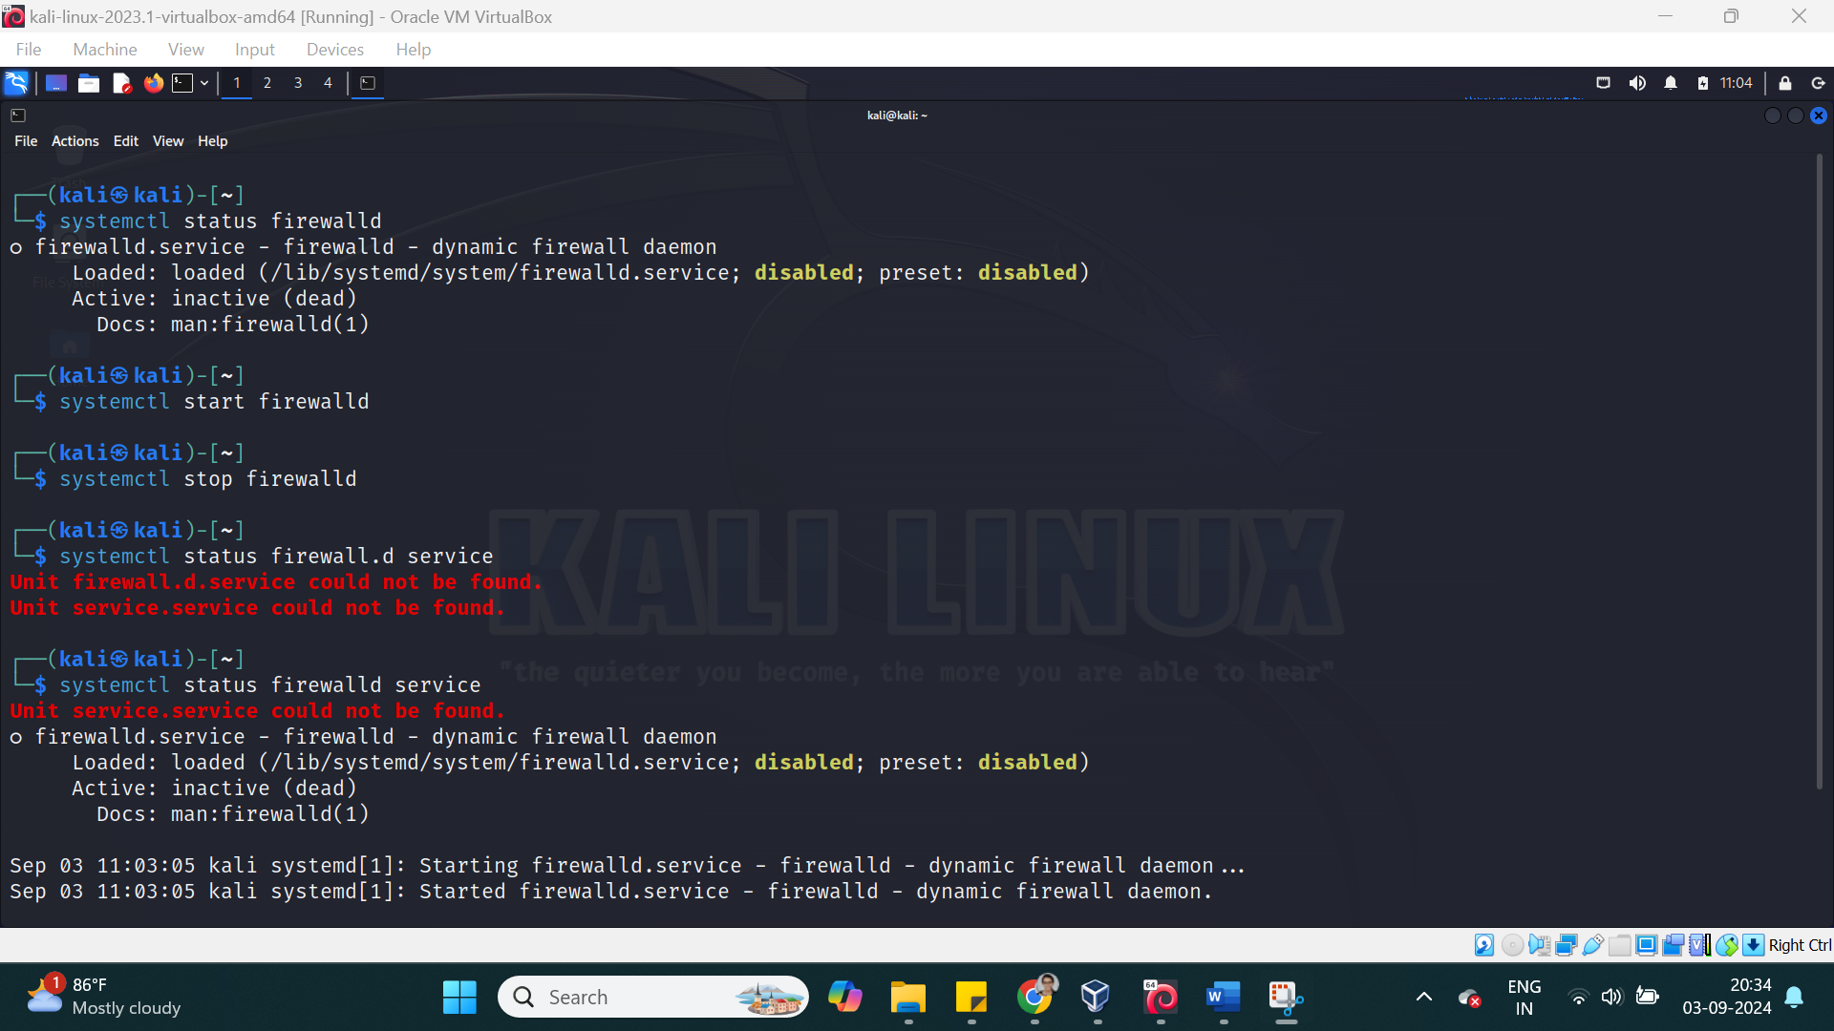

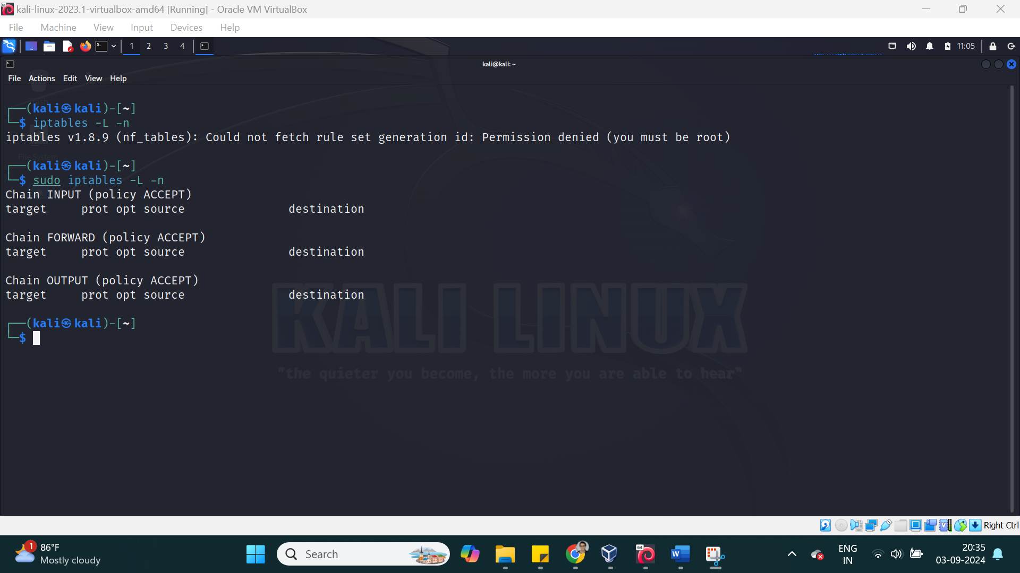

Task: Toc check iptables service is active

command: sudo systemctl status iptables

Task : to start firewall config

command (gui): firewall-config

command (cli): firwall-cmd --list-all

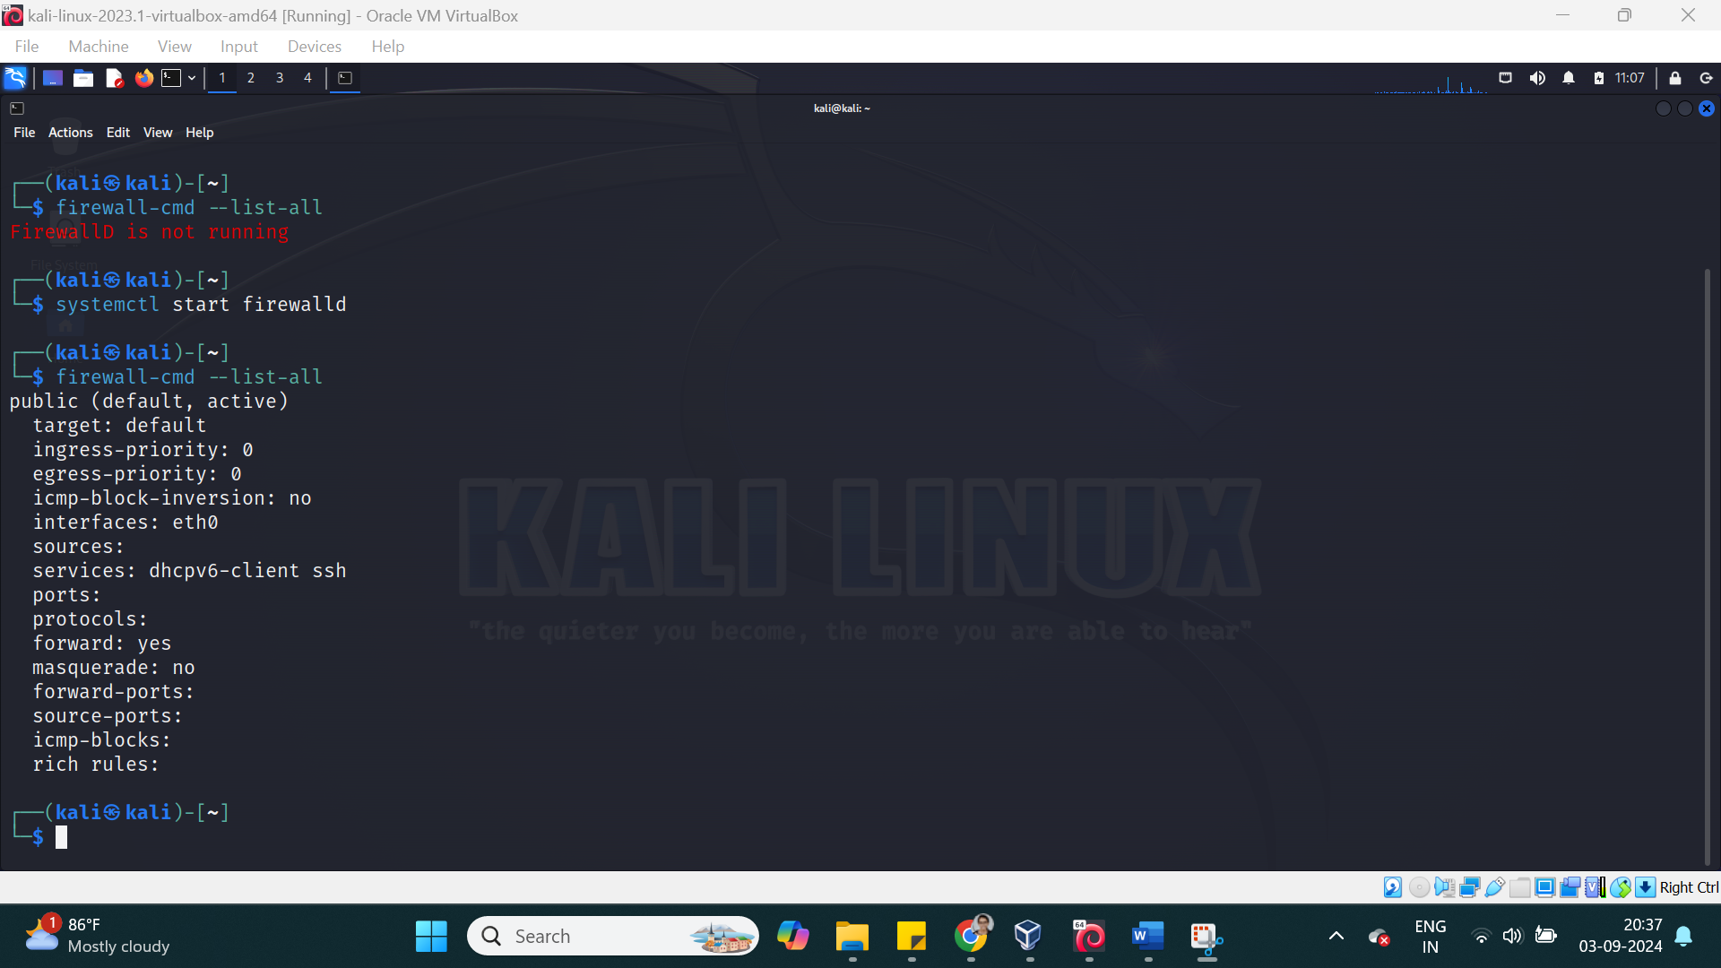

Task: To display the zones

command: sudo firewall-cmd --get-zones

Task: To allow traffic

command: sudo firewall-cmd --add-port=80/tcp --permanent

Task: To check all predefined services

command: firewall-cmd --get-services

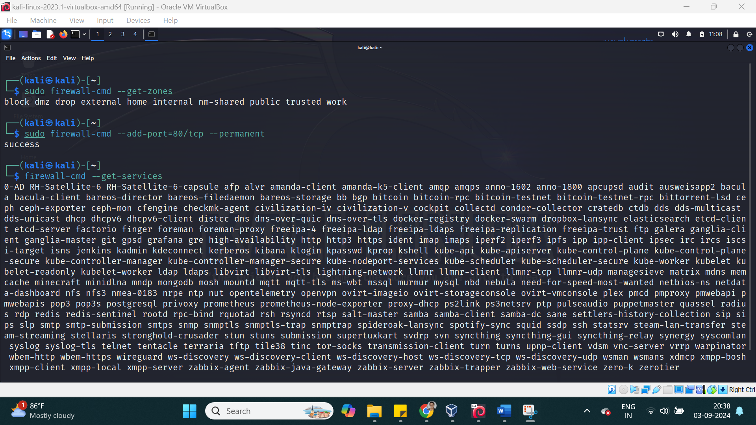

Task: To display all ports and services

command: sudo firewall-cmd --list-all

